​ **WPS ASSIGNMENT - 3**​

**K.Madhuraj Reddy**

**1602-18-733-027**

**1. Create a dynamic web application using JSP’s to do carry on a survey on the students of a college. The survey must consist of 4 pages with 3 questions in each page. You must allow the user to move back and forth among these pages. Once he Submit the survey in the third page, a summary sheet withQuestions and Answers of the survey must be displayed to the user along with OK and Cancel Buttons. If user presses OK save data in database. Some of the questions must accept radio buttons, checkboxes.**

**File Structure:**

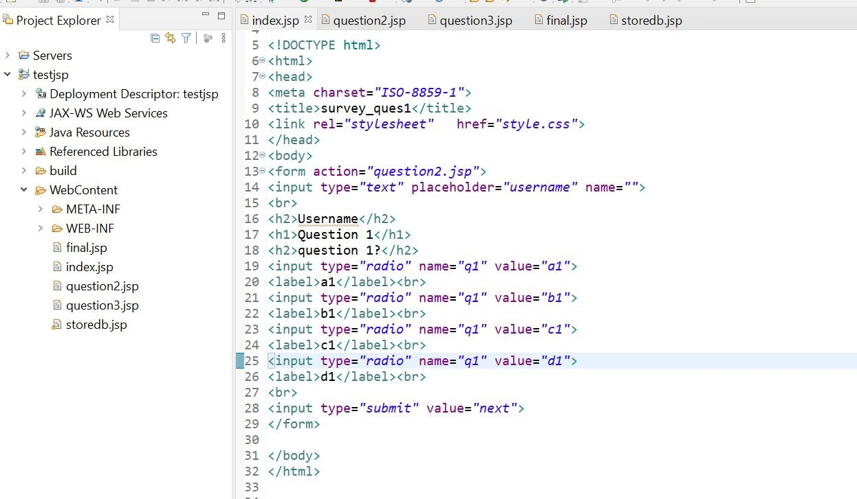

# index.jsp

<%@ page language="java" contentType="text/html; charset=ISO-8859-1" pageEncoding="ISO-8859-1"%>

<!DOCTYPE html>

<html>

<head>

<meta charset="ISO-8859-1">

<title>survey_ques1</title>

<link rel="stylesheet" href="style.css">

</head>

<body>

<form action="question2.jsp">

<input type="text" placeholder="username" name="">

<br>

<h2>Username</h2>

<h1>Question 1</h1>

<h2>question 1?</h2>

<input type="radio" name="q1" value="a1"> <label>a1</label><br>

<input type="radio" name="q1" value="b1">

<label>b1</label><br>

<input type="radio" name="q1" value="c1">

<label>c1</label><br>

<input type="radio" name="q1" value="d1">

<label>d1</label><br>

<br>

<input type="submit" value="next">

</form>

</body>

</html>

# question2.jsp

<%@ page language="java" contentType="text/html; charset=ISO-8859-1" pageEncoding="ISO-8859-1"%>

<!DOCTYPE html>

<html>

<head>

<meta charset="ISO-8859-1">

<title>survey_ques2</title>

</head>

<body>

<%

String q1=request.getParameter("q1");

session.setAttribute("q1",q1);

String username=request.getParameter("username"); session.setAttribute("name",username);

%>

<form action="question3.jsp">

<h1>Question 2</h1>

<h2>Question 2?</h2>

<input type="radio" name="q2" value="a2"> <label>a2</label><br>

<input type="radio" name="q2" value="b2">

<label>b2</label><br>

<input type="radio" name="q2" value="c2">

<label>c2</label><br>

<input type="radio" name="q2" value="d2">

<label>d2</label><br>

<br>

<input type="submit" value="next">

</form>

<a href="index.jsp"><button>back</button></a>

</body>

# </html> question3.jsp

<%@ page language="java" contentType="text/html; charset=ISO-8859-1" pageEncoding="ISO-8859-1"%>

<!DOCTYPE html>

<html>

<head>

<meta charset="ISO-8859-1">

<title>survey_ques3</title>

</head>

<body>

<%

String q2=request.getParameter("q2");

session.setAttribute("q2",q2);

%>

<form action="final.jsp">

<h1>Question 3</h1>

<h2>Question 3?</h2>

<input type="radio" name="q3" value="a3"> <label>a3</label><br>

<input type="radio" name="q3" value="b3">

<label>b3</label><br>

<input type="radio" name="q3" value="c3">

<label>c3</label><br>

<input type="radio" name="q3" value="d3">

<label>d3</label><br>

<br>

<input type="submit" value="next">

</form>

<a href="question2.jsp"><button>back</button></a>

</body>

</html>

# final.jsp

<%@ page language="java" contentType="text/html; charset=ISO-8859-1" pageEncoding="ISO-8859-1"%> <%@ page import ="java.sql.*" %>

<!DOCTYPE html>

<html>

<head>

<meta charset="ISO-8859-1">

<title>survey_final</title>

</head>

<body>

<%

String q=request.getParameter("q3");

session.setAttribute("q3",q);

%>

<h2>question 1?</h2>

<h3>Answer - a1</h3>

<h2>question 2?</h2>

<h3>Answer - b2</h3>

<h2>question 3?</h2>

<h3>Answer - d3</h3>

<%

int i=0;

String q1=(String)session.getAttribute("q1"); out.println("question 1 selected option "+q1); if(q1.equals("a1"))

{

out.println("question 1 correct "); i=i+1;

}

else

{

out.println("question 1 wrong ");

}

%>

<br>

<%

String q2=(String)session.getAttribute("q2"); out.println("question 2 selected option"+q2); if(q2.equals("b2"))

{

out.println("question 2 correct "); i=i+1;

}

else

{

out.println("question 2 wrong ");

}

%>

<br>

<%

String q3=(String)session.getAttribute("q3"); out.println("question 3 selected option "+q3); if(q.equals("d3"))

{

out.println("question 3 correct "); i=i+1;

}

else

{

out.println("question 3 wrong ");

}

out.println("Score = "+i+"/3");

%>

<br>

<a href="storedb.jsp"><button>OK</button></a>

<a href="index.jsp"><button>Cancel</button></a>

</body>

</html>

# storedb.jsp

<%@ page language="java" contentType="text/html; charset=ISO-8859-1" pageEncoding="ISO-8859-1"%>

<%@ taglib uri="http://java.sun.com/jsp/jstl/core" prefix="c" %>

<%@ taglib uri="http://java.sun.com/jsp/jstl/sql" prefix="sql" %>

<!DOCTYPE html>

<html>

<head>

<meta charset="ISO-8859-1">

<title>Thank you</title>

</head>

<body>

<sql:setDataSource var="db" driver="com.mysql.cj.jdbc.Driver" url="jdbc:mysql://localhost/test" user="root" password=""/>

<%

String q1=(String)session.getAttribute("q1");

String q2=(String)session.getAttribute("q2");

String q3=(String)session.getAttribute("q3");

String name=(String)session.getAttribute("name");

%>

<sql:update dataSource="${db}" var="count">

INSERT INTO wpsa3q1 VALUES ('${name}','${q1}','${q2}','${q3}');

</sql:update>

<sql:query dataSource="${db}" var="rs">

SELECT * from wpsa3q1;

</sql:query>

<table border="2" width="100%">

<tr>

<th>S.no</th>

<th>q1</th>

<th>q2</th>

<th>q3</th>

</tr>

<c:forEach var="table" items="${rs.rows}">

<tr>

<td><c:out value="${table.name}"/></td>

<td><c:out value="${table.q1}"/></td>

<td><c:out value="${table.q2}"/></td>

<td><c:out value="${table.q3}"/></td>

</tr>

</c:forEach>

</table>

<h1 style="text-align:centre"><c:out value="${'Thanks for taking survey'}"/> </h1>

<a href="index.jsp"><button>Submit another entry</button></a>

</body>

</html>

# Data Base

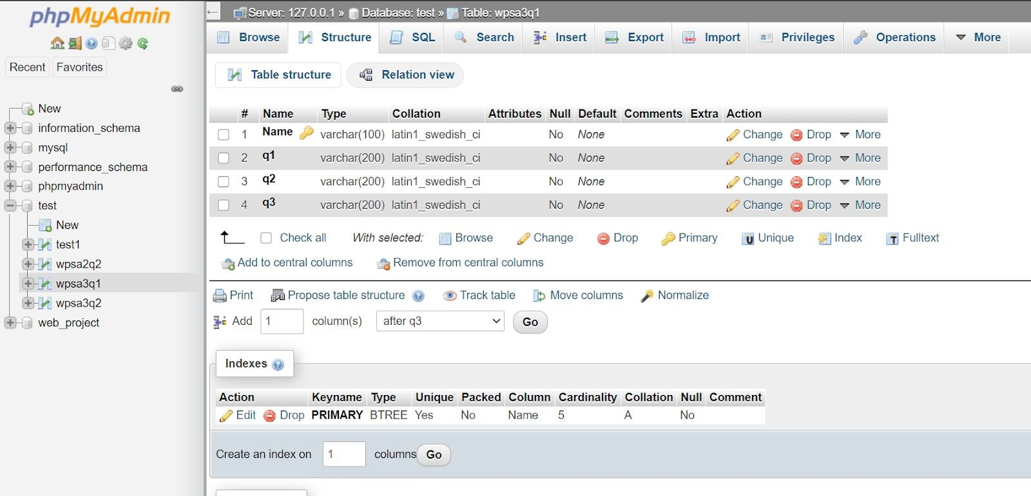

# Output

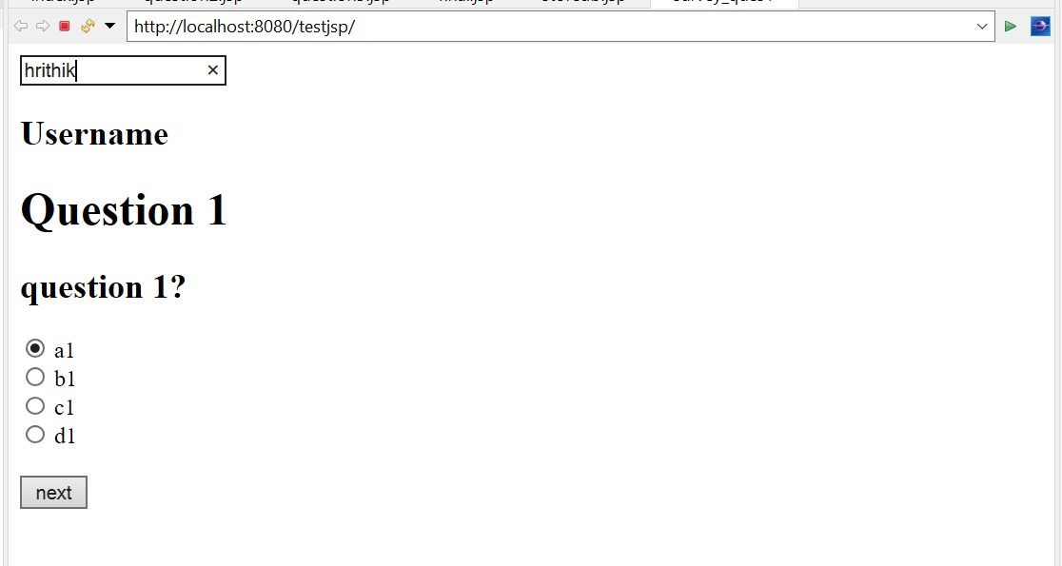

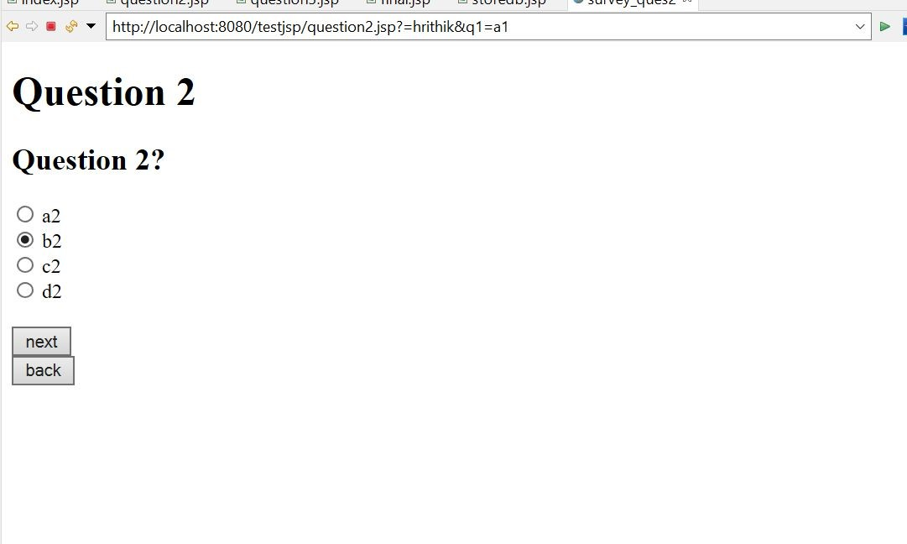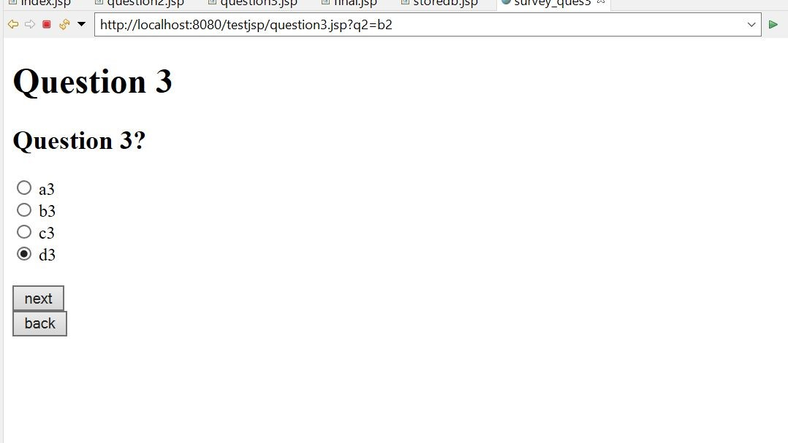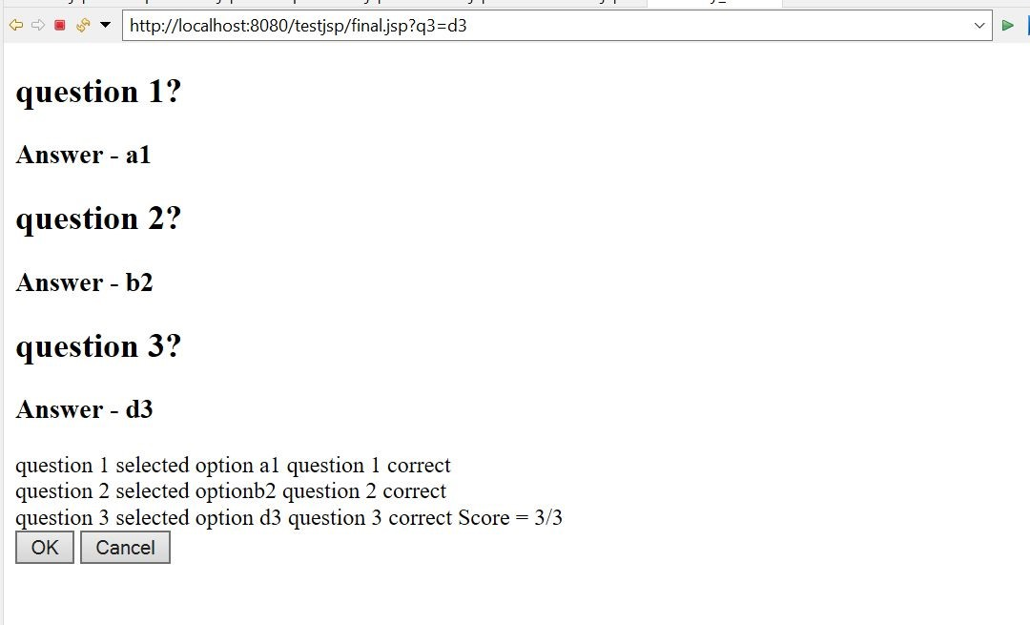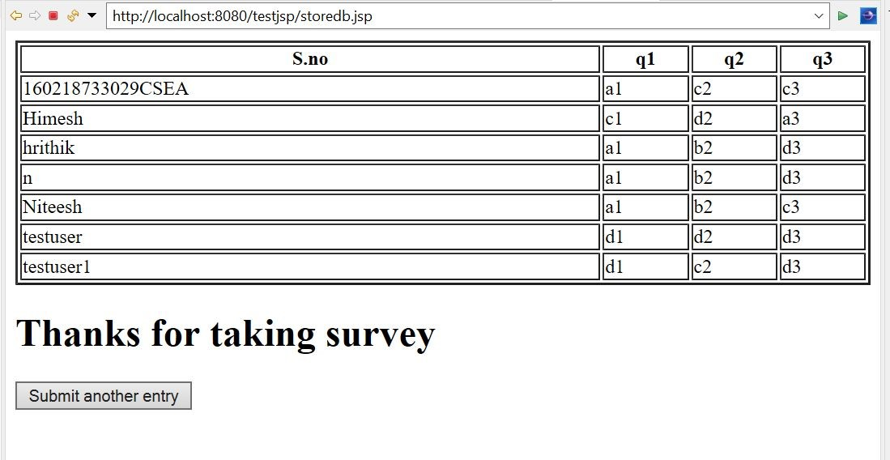

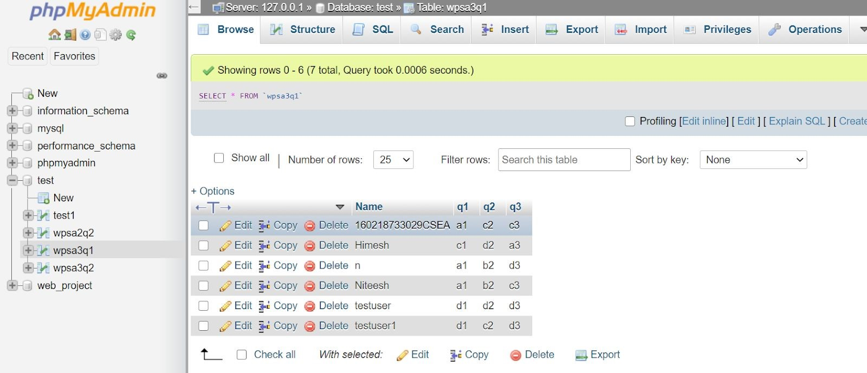

**2. Write a PHP script that obtains a URL and its description from a user and stores the information into a database using MySQL. Create and run a SQL script with a database named URL and a table named Urltable. The first field of the table should contain an actual URL, and the second, which is named Description, should contain a description of the URL.**

# index.php

|  |
| --- |
| <!​DOCTYPE​ ​html​> |
| <​html​> |
|  |
| <​head​> |
| ​<​title​>​Test page​</​title​> |
| ​<​meta​ ​name​=​"viewport"​ ​width​=​"device-width"​ ​initial-scale​=​"1"​ ​/> |
| ​<​script |
| src​=​"https://ajax.googleapis.com/ajax/libs/jquery/3.2.1/jquery.min.js"​></​s |
| cript​> |
| </​head​> |
|  |
|  |
| <​body​> |
|  |
| <​h1​> |
| Enter url |
| </​h1​> |
| <​input​ ​type​=​"text"​ ​placeholder​=​"url"​ ​id​=​"url"​> |

|  |
| --- |
| <​h1​> |
| Description |
| </​h1​> |
| <​input​ ​type​=​"text"​ ​placeholder​=​"description"​ ​id​=​"desc"​> |
| <​br​> |
|  |
| <​button​ ​style​=​"margin-top:30px"​ ​onclick​=​"​adddb​()"​>​Submit​</​button​> |
|  |
| <​script​> |
|  |
| function​ ​adddb​() |
| { |
|  |
| ​var​ ​a​ = ​document​.​getElementById​(​"url"​).​value​; |
| ​var​ ​b​ = ​document​.​getElementById​(​"desc"​).​value​; |
| ​console​.​log​(​a​,​b​); |
|  |
| ​$​.​ajax​({ |
| ​url:​ ​"adddb.php"​, |
| ​type:​ ​"POST"​, |
| ​data:​ { |
| ​url1:​ ​a​, |
| ​desc1:​ ​b​, |
| }, |
| ​success​:​ ​function​ (​data​) { |
| ​console​.​log​(​'data: '​+​data​); |
| }, |
|  |
| ​error​:​ ​function​(​error​) { |
| ​console​.​log​(​'Error: '​ + ​error​); |
| } |
| }); |
|  |
|  |
| } |
| </​script​> |
|  |
| </​body​> |
| </​html​> |
|  |
|  |

# addbd.php

|  |
| --- |
|  |
|  |
| **<?php** |
| ​**include**​​**'db.php'**​**;** |
| ​**$a**​**=**​**$_POST**​**[**​**'url1'**​**];** |
| ​**$b**​**=**​**$_POST**​**[**​**'desc1'**​**];** |
|  |
| ​**$sql**​ **=** ​**"insert into wpsa3q2 VALUES ('**​**$a**​**','**​**$b**​**')"**​**;** |
| ​**$query**​**=**​**mysqli_query**​**(**​**$con**​**,**​**$sql**​**);** |
| ​**if**​**(**​**$query**​**)** |
| **{** |
| ​**echo**​​**"successful"**​**;** |
| **}** |
| ​**else** |
| **{** |
| ​**echo**​​**"Failed"**​**;** |
| **}** |
| **?>** |
|  |

# db.php

|  |
| --- |
| **<?php** |
|  |
| ​**$server**​**=**​**"localhost"**​**;** |
|  |
| ​**$user**​**=**​**"root"**​**;** |
|  |
| ​**$password**​**=**​**""**​**;** |
|  |
| ​**$db**​**=**​**"test"**​**;** |
|  |
| ​**$con**​**=**​**mysqli_connect**​**(**​**$server**​**,**​**$user**​**,**​**$password**​**,**​**$db**​**);** |
|  |
| ​**if**​**(**​**$con**​**)** |
| **{** |
| ​**echo**​​**"successful dbcon"**​**;** |
| **}**​**else**​**{** |
| ​**echo**​​**"Failed dbcon"**​**;** |
| **}** |
| **?>** |

# Database

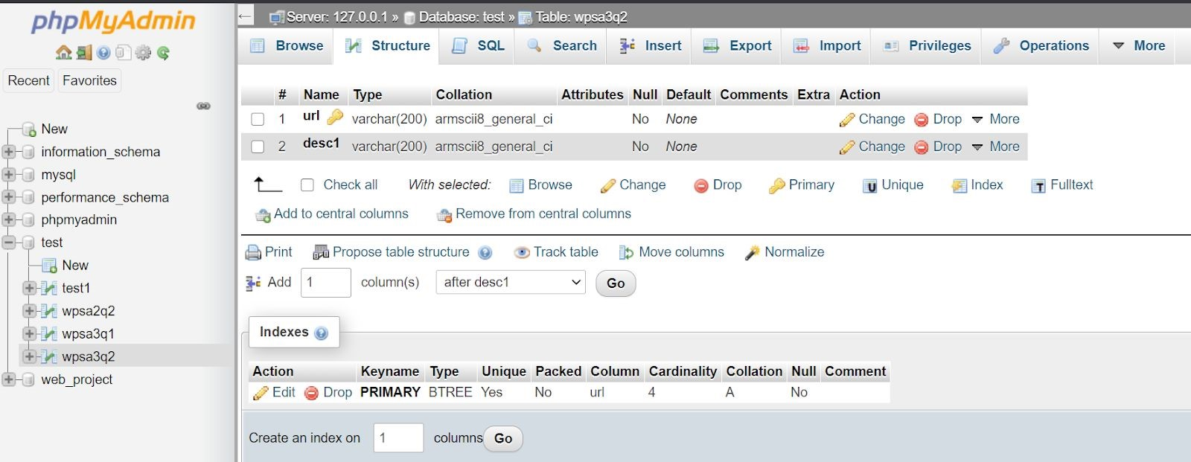

# Output

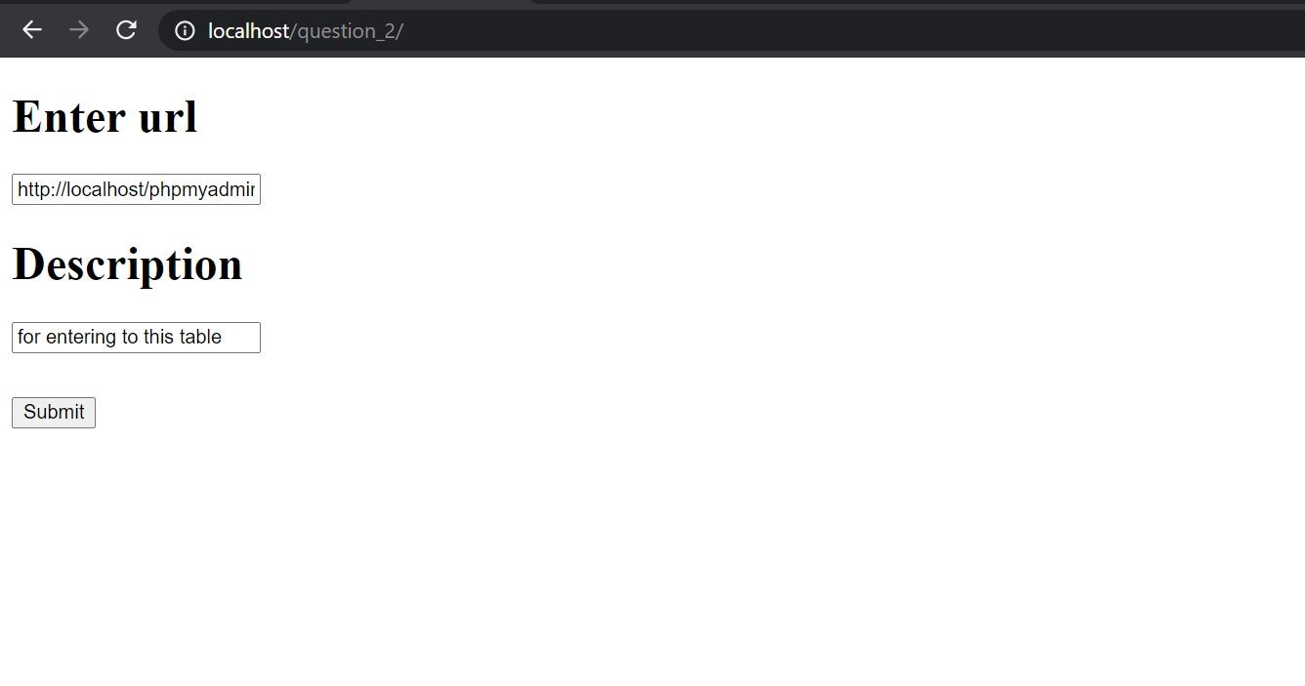

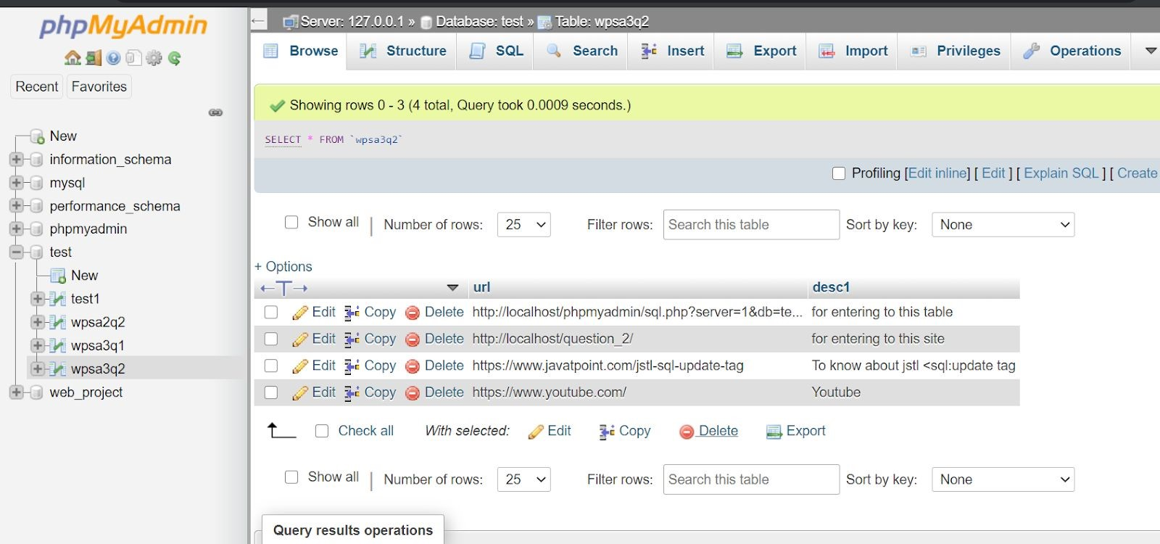

**3. Create a web service client to consume a rest based service hosted at https://reqres.in/api/products/3 to read the users data.**

# index.html

|  |
| --- |
| <​html​> |
| <​head​> |
| <​title​>​Question 3​</​title​> |
| <​meta​ ​name​=​"viewport"​ ​width​=​"device-width"​ ​initial-scale​=​"1"​ ​/> |
| <​script​ ​src​=​"https://unpkg.com/axios/dist/axios.min.js"​></​script​> |
| <​script​ ​src​=​"https://code.jquery.com/jquery-3.1.1.min.js" |
| integrity​=​"sha256-hVVnYaiADRTO2PzUGmuLJr8BLUSjGIZsDYGmIJLv2b8=" |
| crossorigin​=​"anonymous"​></​script​> |
| <​style​> |
|  |
| table​, ​th​, ​td​ { |
|  |
| ​border​: ​1px​ ​solid​ ​black​; |
| ​text-align​: ​center​; |
| ​background-color​: ​rgb​(​245​, ​245​, ​153​); |
| } |
| </​style​> |
| </​head​> |
| <​body​> |

|  |
| --- |
| <​script​> |
| ​axios​.​get​(​'https://reqres.in/api/products/3'​) |
| .​then​(​response​ ​=>​ { |
|  |
| ​console​.​log​(​"This is here"​) |
|  |
| ​let​ ​d​ = ​response​.​data​.​data​; |
| ​let​ ​s​ = ​response​.​data​.​support​; |
|  |
| ​var​ ​output​=​''​; |
| ​output​ +=​` |
|  |
| <table style="width:100%"> |
| <tr> |
| <th>Id</th> |
| <th>Name</th> |
| <th>Year</th> |
| <th>Color</th> |
| <th>Pantone-Value</th> |
| </tr> |
| <tr> |
| <td>​${​d​.​id​}​</td> |
| <td>​${​d​.​name​}​</td> |
| <td>​${​d​.​year​}​</td> |
| <td>​${​d​.​color​}​</td> |
| <td>​${​d​.​pantone_value​}​</td> |
| </tr> |
| </table> |
| `​; |
| ​$​(​'#userdata'​).​html​(​output​); |
| ​var​ ​output1​=​''​; |
| ​output1​ +=​` |
|  |
| <table style="width:100%"> |
| <tr> |
| <th>Url</th> |
| <th>Text</th> |
| </tr> |
| <tr> |
| <td>​${​s​.​url​}​</td> |
| <td>​${​s​.​text​}​</td> |
| </tr> |
| </table> |
| `​; |
| ​$​(​'#support'​).​html​(​output1​); |
|  |
|  |
| }) |
| .​catch​(​error​ ​=>​ { |
|  |
| ​console​.​log​(​error​); |
| }) |
|  |
|  |
| </​script​> |
| <​h1​>​ User Data​</​h1​> |
| <​div​ ​id​=​"userdata"​> |
|  |
|  |
| </​div​> |
| <​h2​>​Support​</​h2​> |
| <​div​ ​id​=​"support"​> |
|  |
|  |
| </​div​> |
|  |
|  |
| </​body​> |
| </​html​> |

# Output

